S O C I A L M E D I A M A R K E T I N G P R O F E S S I O N A L

**ONKAR KOKANE**



PORTFOLIO 2025

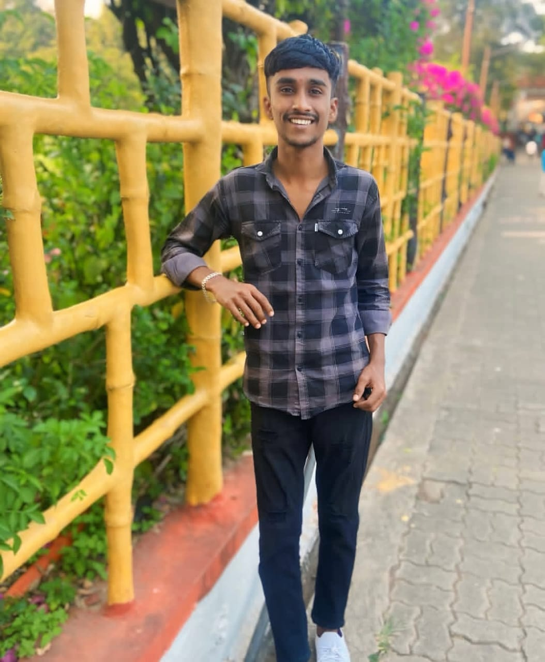   

I 'M ONKAR

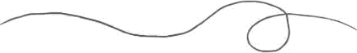

I am a Social Media Marketing Professional with over two years of experience in organic O paid social media marketing, community management and copywriting in the entertainment and Rich industries.

   

I've managed communities as large as =30K on Instagram, =15K on youtube, =2K on LinkedIn and 10K on Facebook. I've helped multiple clients enrich their social media presence by providing full audit of their profiles, growing and engaging with their audience communities, copywriting, managing online reputation, planning and implementing advertising strategies on Instagram, Facebook, LinkedIn and youtube, retrieving anlytics and providing recommendations reflected upon data.

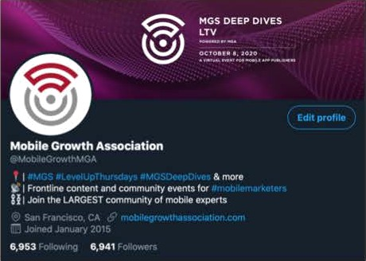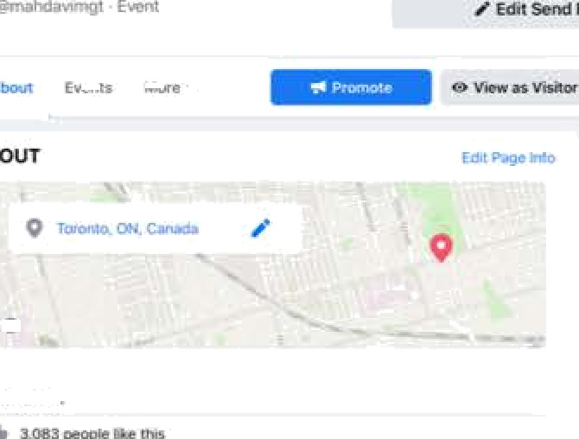

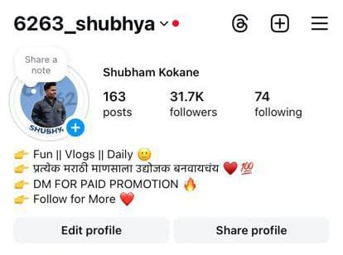

# Impressa 5olutions

(B2B marketing agency)

Responsible for content curation and occasional copywriting/scheduling of social media posts for 5 of their clients.

Impressa Solutions is a hubSpot partner agency, that required me to obtain some of the Hubspot Certifications needed for my role (see below).



|  |  |  |  |
| --- | --- | --- | --- |
| Social Media Marketing | ” | HubSpot Marketing | ” |
| Certification Course |  | Software |  |

W Completed

Completed 

Marketers

MAftK5TING

HubSpot CMS For

W Completed

w Completed VG.certf9cauon

Mobile Growth Association



Increased brand awareness audience engagement on Instagram, Facebook, youtube and linkedIn. Drove organic social media traffic of 9,000 sessions to the website generated = 3,000 link clicks on Facebook campaigns over the past quarter. Grew Instagram audience by 100%, LinkedIn by 19% and Facebook by 6% within 6 months.

Total Page Followers as of Today: 2,163

Total Page Followers

.,-m .-W .m.t.œ,w

Sessions -

. .....

,.

*•””“”“””*’t

...! , .. ,.. , .! .

” É É

## Mobile Growth Association

Organic Social Media

* Content planning for 5 days a week/1-3 posts per day for Facebook, Instagram, Twitter and LinkedIn
* Proactive and reactivate social media engagement and reputation management on all social media platforms
* Managing two LinkedIn groups for event attendees and members as a part of community engagement



# Mobile Growth Association

Paid Social Media



I .;i , i' /'t:› • '.' •Q' ! . . - • . . *

1,447,g 6 -• • s2,85s.eo -• • 3,isz,372 • 29,980 • w

* Successfully launched If analyzed 40 paid campaigns on ‘.°"°'” ‘“ Facebook & Instagram, Twitter and LinkedIn.

”“"‘*



e

* Created multiple target audiences to meet each campaign's needs



    



# 6263_shubhya

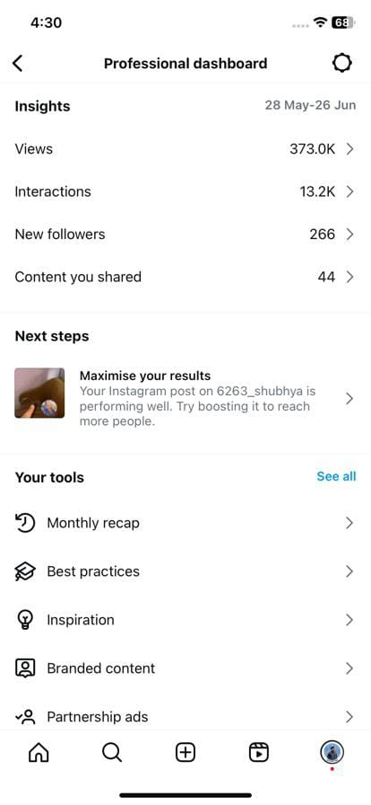

Audience Growth and Profile Optimization

* By managing their Facebook page I was able to grow its following by 58%, boost post engagement by 1039% and reach 281% more people within 1 month just by organic optimization of the profile.
* Gained =1,000 followers as a result of proactive engagement with profiles following similar artist pages on Instagram

Homa Events About Photos More



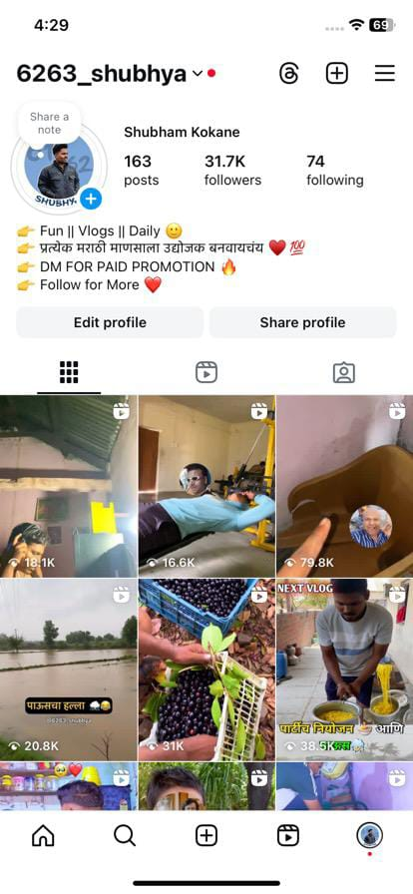6263_shubhya (2O24 work)

* content planning for 3-5 posts per week for Facebook and Instagram
* Proactive & reactive engagement on both profiles that increased Facebook following by 4% & Instagram by 20%
* Active engagement & promotion in Facebook groups to bring in more event attendees
* Basic video editing and graphic creation for promotionl assets

## YOUTUBE management

* **Client Name/Channel (optional):** SonOfFire
* **Niche:** gamer& Lifestyle
* **Tasks Done:**
  + Created monthly content calendar and video ideas
  + Researched trending topics and optimized for SEO
  + Suggested growth strategy to increase subscribers and watch time
* **Tools Used:** Google Trends, TubeBuddy, Notion
* **Results:** Gained +4K subscribers in 6 months, watch time increased by 20%

 

Social Media Strategy

Copywriting Profile Audit

Keyword, Hashtag & Competitor Research Profile Optimization

Content Calendar Planning

Social Media Advertising (Facebook, Instagram,

_ Twitter and LinkedIn)

Basic Graphics Creation (Canva) Community Engagement

  

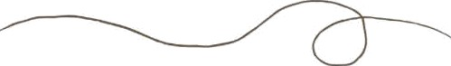

Emăil

[kokaneonkar.sae.com@gmail.com](mailto:Julia.bbchv@gmail.com)

### Instagram

@onkya4646 and achivers.thoughts

### Phone

+91S9762758336